Yarmouk University


Information Technology and Computer Science
Information Systems (IS)

Smart Focus Student Monitoring system

Sarah Fouad Abdel Latif Al-Hawamdeh 2022902058
Heba Zyad Mohammed Odibat 2021902136

Supervisor
Dr.Abrar Abedalhaq

Acknowledgement

- Introduction

In modern educational environments, monitoring student attention during lectures is crucial for effective learning. Many students experience boredom or drowsiness inside classrooms, especially with long and consecutive lectures without sufficient breaks, which negatively affects their ability to focus, comprehend, and actively participate. Traditional methods of assessing student attention rely on teachers’ subjective observations, which may not accurately reflect the actual level of students’ concentration or mental fatigue.

With the rapid advancement of Artificial Intelligence (AI) and Computer Vision, it is now possible to develop intelligent systems capable of analyzing students’ attention in real-time and objectively. This project aims to design a smart system for monitoring student focus in the classroom using AI techniques, with the goal of supporting the educational process and enhancing the learning experience from both the students’ and instructors’ perspectives. The system provides teachers with precise and actionable insights into individual and overall class engagement, enabling timely interventions—such as adjusting teaching methods or incorporating short breaks—to reduce boredom and drowsiness and improve learning outcomes..

- Project Overview and Objectives

Project Overview
The proposed system is an intelligent platform designed to monitor student focus during lectures using classroom cameras, which we implement as students using a computer camera. Many students often experience drowsiness or boredom during long or consecutive lectures, negatively affecting their understanding and participation. This system analyzes eye movements and head posture to accurately evaluate attention levels in real-time.

The system features an interactive dashboard that continuously displays individual and class-wide focus metrics. Instructors can start and stop monitoring sessions, receive immediate alerts when overall attention drops below a certain threshold, and access detailed reports for current and past lectures. The system also includes random student selection and short interactive questions to re-engage students and maintain their focus throughout the lecture.

This approach aims to bridge the gap between students and instructors by providing actionable insights, enabling evidence-based teaching decisions, improving classroom engagement, and enhancing the overall learning experience.

- Literature review
Several systems have been developed to monitor student attention in both traditional classrooms and online learning environments. These systems use various techniques to assess focus, engagement, and participation.
1. Gaze Tracking Systems
- Function: These systems monitor eye movements to estimate the student’s attention level.
- Technologies Used: Camera-based tracking, OpenCV, AI algorithms.
- Strengths: High accuracy in detecting visual attention.
- Weaknesses: Lack of real-time feedback for instructors and no integrated dashboard.
2. Facial Expression Analysis Tools
- Function: Analyze facial cues to evaluate emotions and engagement.
- Technologies Used: Machine Learning models, OpenCV, Mediapipe.
- Strengths: Can detect engagement and emotional states.
- Weaknesses: Often lacks classroom-level integration and actionable alerts.
3. AI-Based Classroom Monitoring Systems
- Function: Combine multiple indicators of attention, such as eye movement, head posture, facial expressions, and sometimes audio interaction.
- Technologies Used: AI, Computer Vision, Deep Learning, Audio Analysis.
- Strengths: Comprehensive analysis of student attention.
- Weaknesses: Some systems still do not provide interactive dashboards or historical data reports.
Relation to Our Project
While existing systems provide gaze tracking or facial expression analysis, they often lack integrated dashboards, real-time alerts, and historical reporting. Our system combines multiple indicators of student attention and delivers actionable insights through a user-friendly interface. Additionally, it provides audio alerts and stores historical data to generate analytical reports for better teaching strategies.

- Requirement Phase
List of functional requirements
The system should allow instructors to log in if they already have an account.
The system should allow instructors to create a new account (Sign Up) if they do not have one.

The system should display the available courses to the instructor after login.
The system should allow the instructor to select a course to start monitoring.

The system should enable real-time monitoring of students’ focus through the computer camera.
The system should analyze facial expressions, eye movement, head posture, and audio interactions to assess attention.

The system should provide automatic audio alerts when student focus drops below a threshold.
The system should allow the instructor to stop the monitoring session by pressing “Stop and Save”.

The system should save the session data, including individual student focus and overall class attention.
The system should provide an interactive dashboard showing individual and overall focus percentages.

The system should allow access to historical data of previous lectures.
The system should display detailed reports for each lecture when the instructor clicks on a specific session.
The system should generate analytical reports including date, time, individual focus, and overall focus metrics.

List of non-functional requirements
• Performance: The system must process video and analyze student focus in real-time with minimal latency.
• Usability: The system should provide a simple, user-friendly interface with clear buttons for starting, stopping, and accessing data.
• Security: The system must protect login credentials, ensure student data privacy, and prevent unauthorized access..
• Scalability: The system should be able to accommodate new courses or a larger number of students without significant modifications.
• Maintainability: The system should be implemented with clean and organized code to facilitate future maintenance and feature expansion.

- Analysis Phase

  - Use Case Diagrams
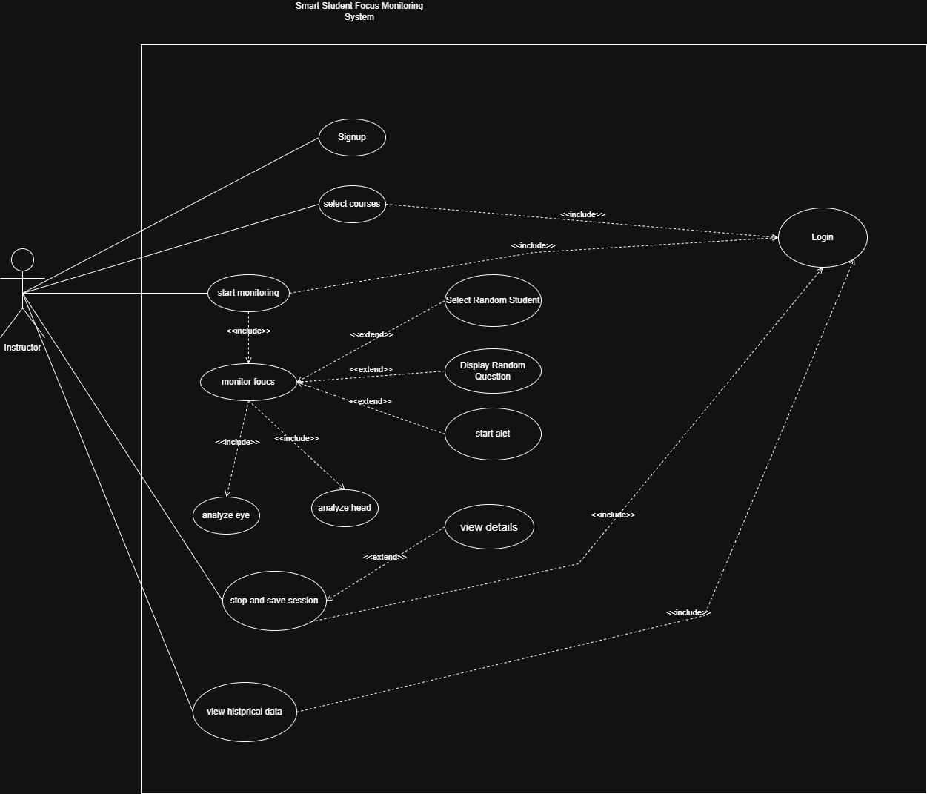

b.Use Case Specifications

1. Signup
- Use Case name: Signup
- Actors: Instructor
- Description: This use case describes how a new instructor creates an account to use the system.
- Normal flow:
  - The instructor selects the "Sign Up" or "Create Account" option.
  - The system requests the instructor to enter their Full Name, Email, and Password.
  - The instructor enters the required information.
  - The system validates that the email is not already in use.
  - The system creates a new record in the database.
  - The instructor is redirected to the login page or the dashboard.
- Alternative flow:
  - Email Already Exists: System shows an error message "This email is already registered."
  - Incomplete Data: System shows an error message "Please fill in all fields."
- Pre-conditions: The instructor must not already have an account associated with the provided email.
- Post-conditions: A new user record is successfully added to the "Instructors" table in the database.

2. Login
- Use Case name: Login
- Actors: Instructor
- Description: This use case describes how an instructor logs into the system to access their dashboard.
- Normal flow:
  - The instructor opens the login interface.
  - The system requests the instructor to enter their email and password.
  - The instructor enters their credentials.
  - The system validates the credentials against the database.
  - The system redirects the instructor to the main dashboard.
- Alternative flow:
  - Invalid Email: System shows an error message "Email not found."
  - Invalid Password: System shows an error message "Incorrect password."
  - Empty Fields: System prompts the user to fill in all required fields.
- Pre-conditions: The instructor must have a registered account in the system.
- Post-conditions: The instructor is granted access to the system’s features and their session begins.

3.Select Courses
- Use Case name: Select Courses
- Actors: Instructor
- Description: This use case describes how the instructor selects a specific course and section from their assigned list to begin a monitoring session or view data.
- Normal flow:
  - The instructor logs into the system and reaches the dashboard.
  - The system displays a list of courses assigned to that instructor.
  - The instructor selects a specific course.
  - The system confirms the selection and enables the "Start Monitoring" or "View history" options for that specific section.
- Alternative flow:
  - No Courses Assigned: The system shows a message "No courses found for your account."
- Pre-conditions: The instructor must be successfully logged into the system.
- Post-conditions: A specific course and section are set as the "active" context for the next operation (Monitoring or Data Review).

4.Start Monitoring
- Use Case name: Start Monitoring
- Actors: Instructor
- Description: This use case describes how the instructor initiates the live tracking of student focus using the camera and AI model.
- Normal flow:
  - The instructor clicks the "Start Monitoring" button on the dashboard.
  - The system checks if a course and section have been selected.
  - The system requests access to the camera (integrated or external).
  - The system starts the video stream and begins real-time analysis.
  - The system calls the "Monitor Focus" use case to process the frames.
  - The system displays the live focus scores and statistics on the screen.
- Alternative flow:
  - Camera Error: System shows a message "No camera detected" and fails to start.
- Pre-conditions:
  - The instructor must be logged in.
  - A specific course and section must be selected.
- Post-conditions: The system is actively recording focus data and updating the session records in the database.

5.Stop and Save Session
- Use case name: Stop and Save Session
- Actors: Instructor
- Description: This use case describes how the instructor ends the monitoring session and how the system calculates and saves the final focus data.
- Normal flow:
  - The instructor clicks the "Stop Session" button to terminate the monitoring.
  - The system stops the video stream and camera access.
  - The system calculates the final average focus score for the entire session.
  - The system displays a summary of the session results to the instructor.
  - The system saves the session record (including date, duration, and average focus) into the database.
- Alternative flow:
  - Saving Failed: The system shows an error message "Database Connection Error" and suggests trying to save again.
  - Accidental Close: If the browser or app closes before clicking stop, the system attempts to auto-save the last recorded data.
- Pre-conditions:
  - A monitoring session must be currently active and running.
  - The system must be connected to the database.
- Post-conditions:
  - The session is officially closed.
  - The final data is stored and becomes available in the "Historical Data" section.

6.View Historical Data
- Use case name: View Historical Data
- Actors: Instructor
- Description: This use case describes how the instructor accesses and reviews focus reports and statistics from previous monitoring sessions.
- Normal flow:
  - The instructor selects the "View Historical Data" option from the main menu.
  - The system retrieves a list of all past sessions associated with the instructor from the database.
  - The instructor filters or searches for a specific session by date, course, or section.
  - The system displays a summary of the selected session, including the overall average focus score.
- Alternative flow:
  - No Data Found: The system displays a message "No historical records found for this account."
  - Database Connection Error: The system shows an error message and asks the instructor to refresh the page.
- Pre-conditions:
  - The instructor must be successfully logged into the system.
  - There must be previously saved sessions in the database.
- Post-conditions: The instructor successfully views the analytics and focus trends of past lectures.

7.Monitor Focus
- Use Case name: Monitor Focus
- Actors: System (AI Engine) and Instructor
- Description: This use case describes the internal process of analyzing student behavior using AI.
- Normal flow:
  - The system captures video frames of the students.
  - The system analyzes eye gaze (Analyze Eye).
  - The system analyzes head orientation (Analyze Head).
  - The system calculates a focus percentage score for each student.
  - The system updates the average focus score for the whole session.
- Pre-conditions: The "Start Monitoring" use case must be active.
- Post-conditions: Focus data is calculated and ready to be saved.
B.Activity Diagrams for all complicated behaviors

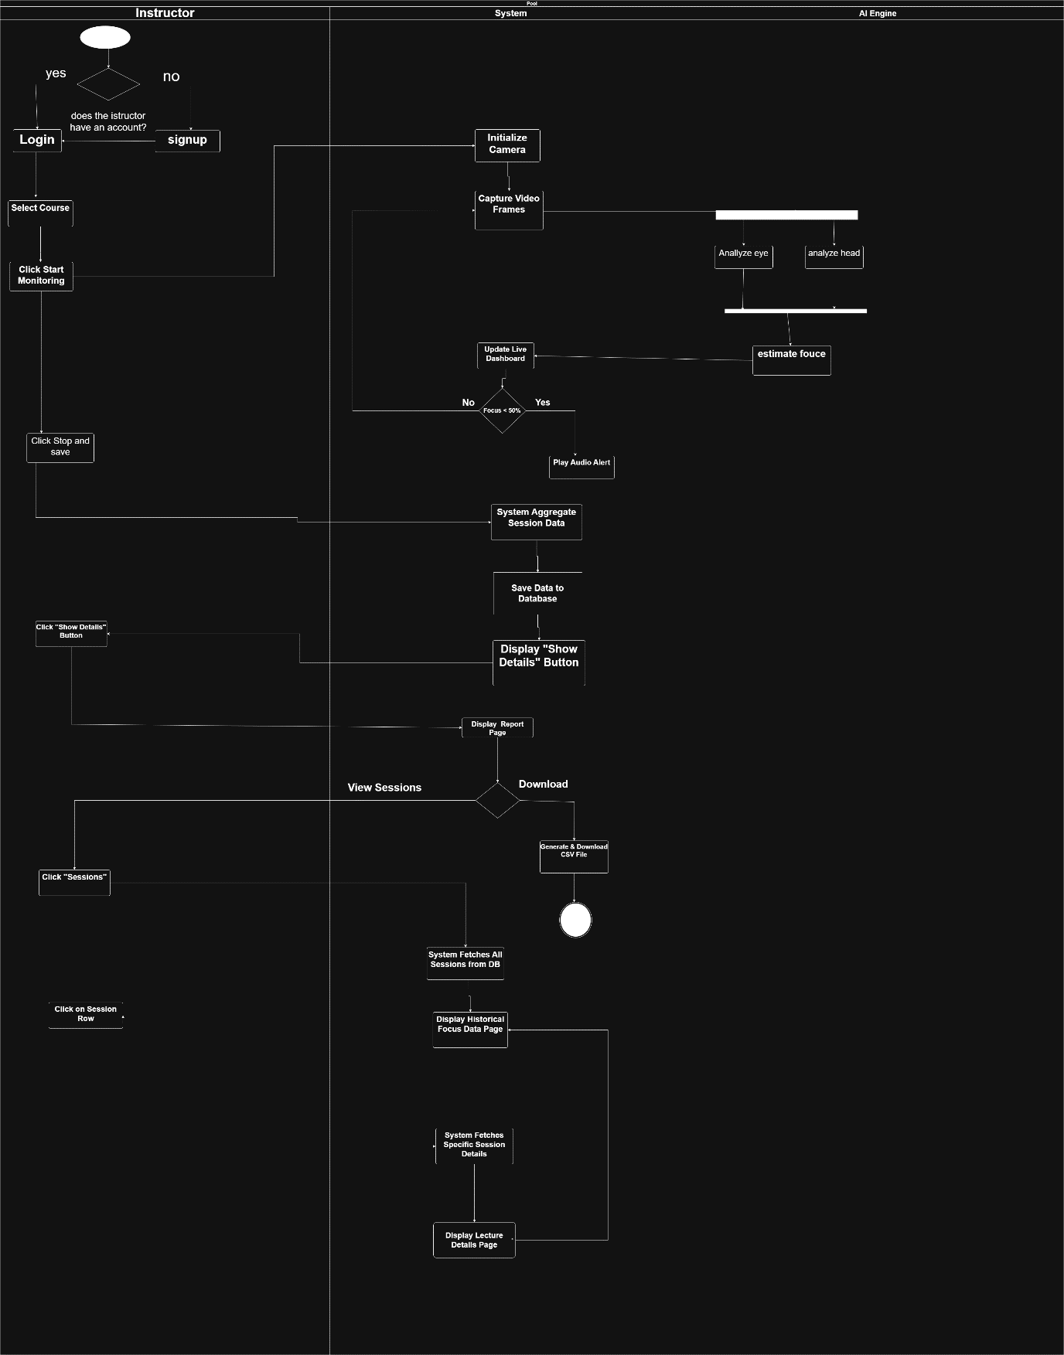

- Design Phase
  - Application Architecture Design (Context Diagram)

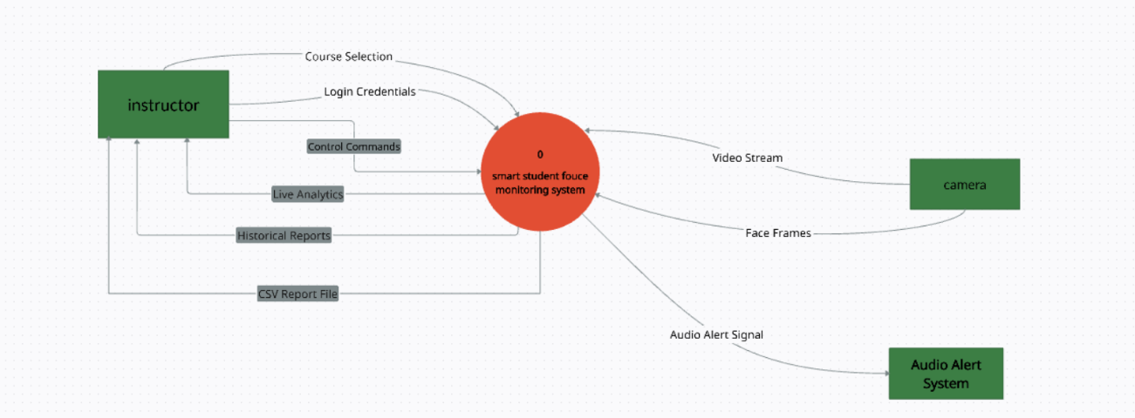

  - Data Architecture Design
